Ranking and Window Functions

. Use ROW_NUMBER() to assign a unique rank within each category.

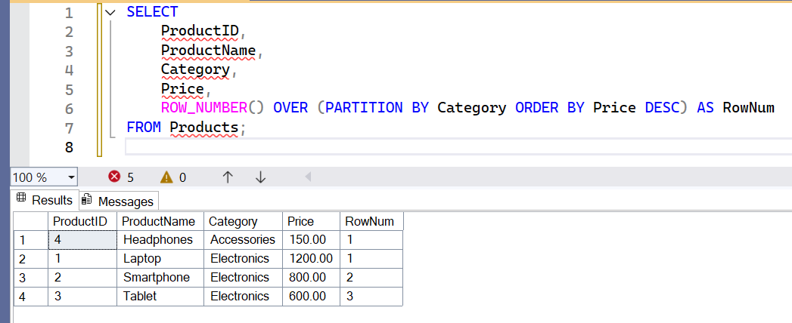

. Use RANK() and DENSE_RANK() to compare how ties are handled

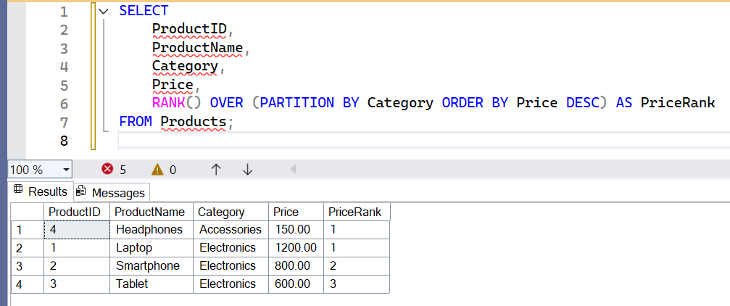

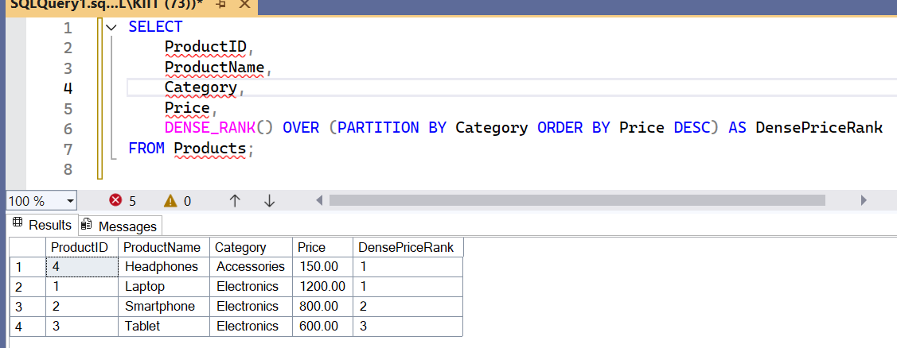

Use PARTITION BY Category and ORDER BY Price DESC

